Sarcoma.
Stem: A 55-year-old male presents to your office after being referred from his PCP for further valuation of an asymptomatic mass on his right inner thigh.
PMH: None. Family history is noncontributory.
PE: There is poorly defined posterior right thigh mass, approximately 8 cm in diameter (specify compartment, posteriormedial in this case based on picture, involving the hamstrings)
Labs: Not significant.

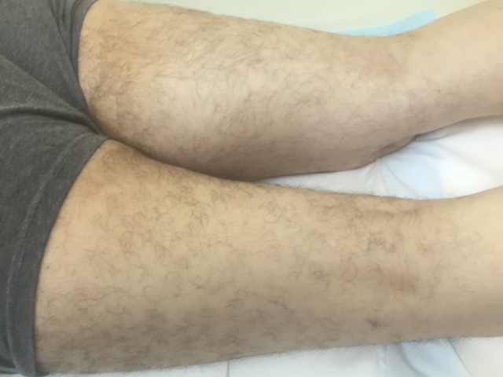
Describe how you would work up and manage this mass?
- Plain radiograph of the thigh: Soft tissue mass with fat density (Need to start with plain radiograph to r/o periosteal or bone involvement)
- MRI of the entire muscle compartment:Soft tissue mass, with low signal intensity on T1 and high signal intensity on T2
- Obtain image-guided core needle biopsy with multiple passes of 18g needle with site incorporated into possible resection margin →pathology:high grade pleomorphic sarcoma
- Staging workup: CT of chest
What if the core needle biopsy came back as non-conclusive? -Obtain incisional biopsy-describe Technique.-Along the axis and don’t develop fascial planes.
Mass is high grade, how would you approach this mass from an operative standpoint?
Radiate first
- limb salvage.
- Excision outside the pseudocapsule.
- Radical resection of the muscle compartment Preserve sciatic

When Is amputation indicated? - Inability to resect without amputation,
nonfunctional limb

Scenario : A 32-year-old man with a history of FAP presents with a 15-cm firm mass in the right axilla that restricts his range of motion. A CNB confirms a desmoid tumor, imaging doesn’t show nerve involvement, patient requests excision, how would you council them regarding risk of recurrence.?

- >50% chance of recurrence even with R0 resection

What if the mass was asymptomatic? -
- Observe.
- Consider medical management with sulindac or other NSAIDs or tamoxifen.

What if this was a 32-year-old female and the mass was discovered during
pregnancy?
- Post-partum give sulindac or tamoxifen or observe.
- Most regress once hormonal stimulation removed.

Scenario 3: A 62-year-old man is seeing you in your office for the first time. He previously underwent exploratory laparotomy and resection of dedifferentiated liposarcoma 3 years ago and has now developed vague symptoms, including early satiety and abdominal bloating. He was lost to follow-up after his initial surgery. What would you recommend?
- Suspect recurrence
- Complete imaging workup including CT Chest/Abd/Pelvis

Your work up shows recurrence, when would recurrence be resectable?

In general, surgery is indicated if R1 resection possible

What if unresectable? recurrence → chemotherapy (ifosfamide/doxorubicin)

